Experiment-3

Aim-To study A* search algorithm

Steps:

• **Initialize:**

* Create an open list (priority queue) and add the start node to it.
* Create a closed list (to keep track of visited nodes).

• **Loop:**

* While the open list is not empty:
  + **Pick the node** with the lowest f-value (f = g + h) from the open list.
  + If this node is the **goal node**, reconstruct the path and return it.
  + Move the current node to the closed list.

• **Expand the Node:**

* For each neighbor of the current node:
  + If it is not in the closed list, calculate its f-value and add it to the open list if necessary.
  + Set its parent to the current node.

• **Repeat** until the open list is empty or the goal is found.

• **Path Reconstruction:**

* Once the goal node is reached, reconstruct the path from the start node to the goal by following parent pointers.

Code:

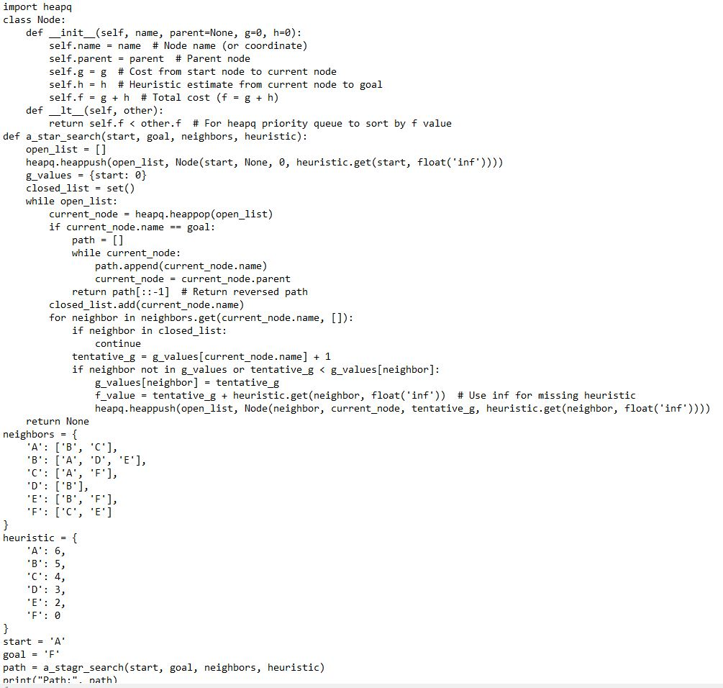

Output:

Path:[‘A’,’C’,’F’]

Result: The A* search algorithm is studied and verified successfully.